ADTA 5550: Deep Learning with Big Data

Assignment 4

1. PART I: Build, Train, and Test CNN on MNIST Dataset

**Model Design:**

* **Input Layer:** 28x28 grayscale images
* **Convolutional Layer 1:** 32 filters, 5x5 kernel, ReLU activation
* **Pooling Layer 1:** 2x2 max pooling
* **Convolutional Layer 2:** 64 filters, 5x5 kernel, ReLU activation
* **Pooling Layer 2:** 2x2 max pooling
* **Flatten Layer:** Converts 2D matrix to 1D vector
* **Fully Connected Layer 1:** 1024 units, ReLU activation
* **Dropout Layer:** Dropout rate of 0.5
* **Fully Connected Layer 2:** 10 units, softmax activation (for 10 classes)

**Training Configuration:**

* **Optimizer:** Adam
* **Loss Function:** Sparse Categorical Cross-Entropy
* **Metrics:** Accuracy
* **Batch Size:** 128
* **Number of Steps:** 5000

**Results:**

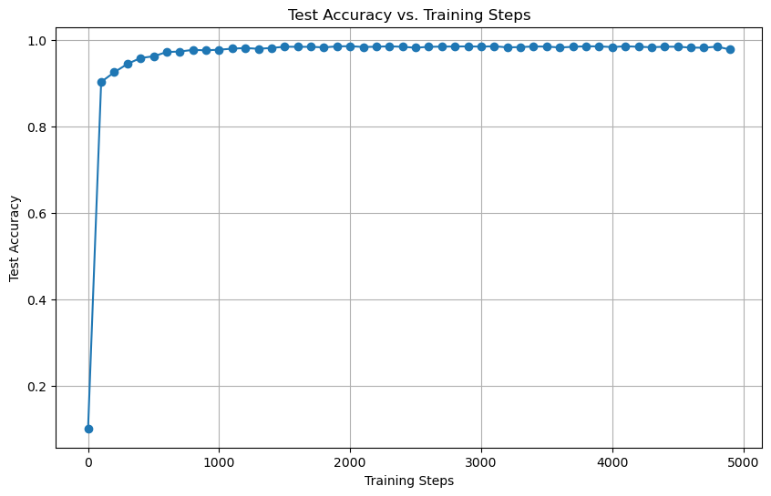

1. PART II: Redesign Convolutional Neural Network (30 Points)

**Updated Model Design:**

* **Input Layer:** 28x28 grayscale images
* **Convolutional Layer:** 32 filters, 5x5 kernel, ReLU activation
* **Pooling Layer:** 2x2 max pooling
* **Flatten Layer:** Converts 2D matrix to 1D vector
* **Fully Connected Layer 1:** 1024 units, ReLU activation
* **Dropout Layer:** Dropout rate of 0.5
* **Fully Connected Layer 2:** 10 units, softmax activation (for 10 classes)

**Updated Training Configuration:**

* **Optimizer:** Adam
* **Loss Function:** Sparse Categorical Cross-Entropy
* **Metrics:** Accuracy
* **Batch Size:** 128
* **Number of Steps:** 5000

**Result Accuracy is: 0.9854**

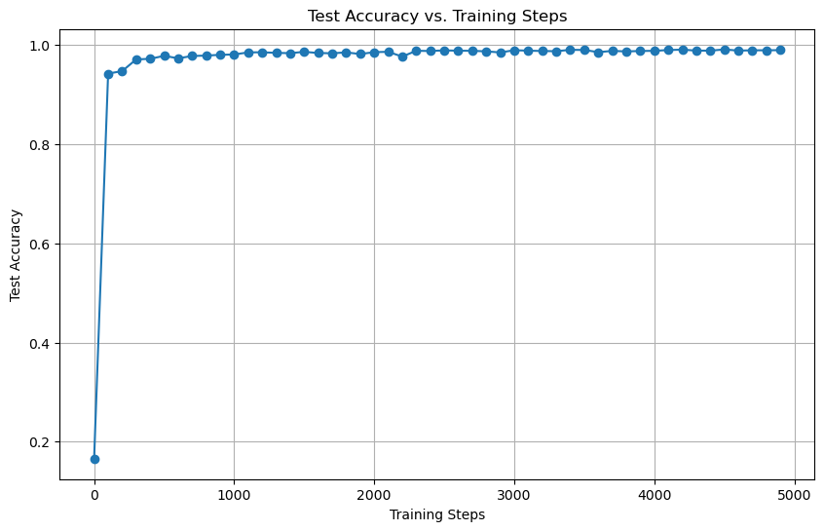

1. PART III: Update Number of Steps of Training CNN Model (10 Points)

**Updated Training Configuration:**

* **Optimizer:** Adam
* **Loss Function:** Sparse Categorical Cross-Entropy
* **Metrics:** Accuracy
* **Batch Size:** 128
* **Number of Steps:** 3000

Result:

